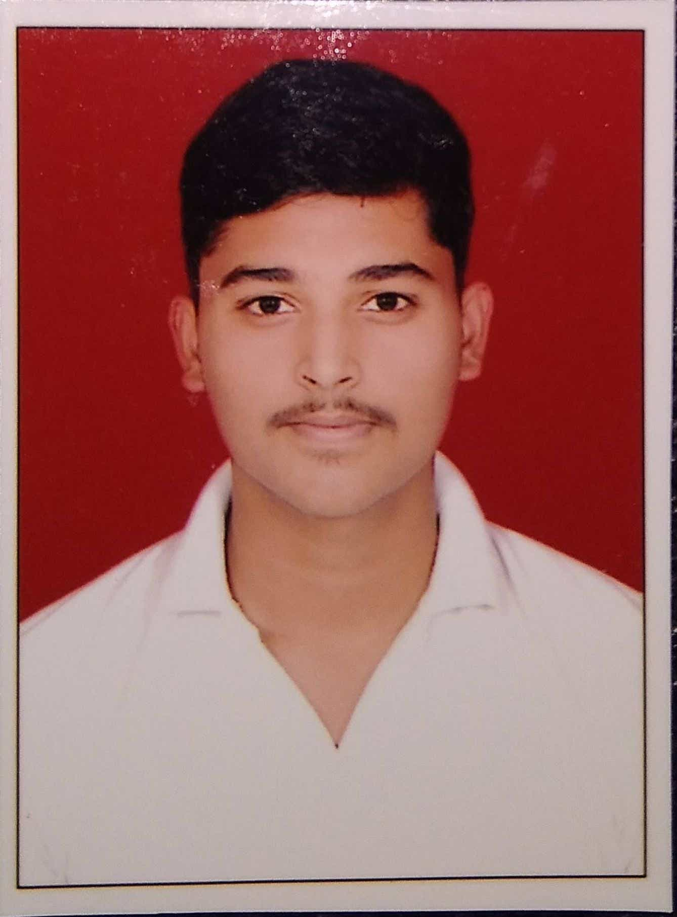

**Sahil Sanjay Thite**

College : NBN Sinhgad School Of Engineering Ambegaon (BK),Pune

Email : sahilthite.nbnssoe.comp@gmail.com

LinkedIn: [**linkedin.com/in/sahil-thite-871203221**](https://www.linkedin.com/in/sahil-thite-871203221)

Mob. : +91 7276371372

# CAREER OBJECTIVE

To secure a challenging position in a reputed organization where I can apply my skills and expand my learnings & knowledge.

# EDUCATIONAL DETAILS

|  |  |  |  |  |
| --- | --- | --- | --- | --- |
| **Class** | **Board/University** | **Institution** | **Year of passing** | **Percentage**  **/CGPA** |
| B.E (Comp) | SPPU | NBN Sinhgad School of Engineering Pune | 2023 | 7.36 (till fourth Sem.) |
| HSC | State Board | Sinhgad College of Arts,Science & Commerce  Ambegaon, Pune | 2018 | 60.00% |
| SSC | State Board | Abhinav Education Society  Ambegaon, Pune | 2016 | 89.20% |

# TECHNICAL SKILLS

* Programming Language : C++ ,C, Core Java ,SQL
* OS : Windows
* Tools: Eclipse, MySQL

# CERTIFICATIONS

* Completed a Certification course in Core Java from JBK.
* Completed a Certification course in SQL from JBK.
* Currently pursuing a J2EE Certification course.

# Area of Interest

* Object Oriented Programming (OOP)
* Web Page Development

# HOBBIES

* Swimming
* Trekking
* Playing Guitar
* Badminton

# Co-Curricular Activities

* Active participation in college and inter-college level technical and non-technical events & workshops
* Sinhgad Karandak Sponsorship team member 2020 & Volunteer of Sinhgad Karandak 2019.
* Crowd Volunteer for Freshers 2k19 Event.

# Personal Details

Nationality : Indian

Date of Birth : 27th March 2000

Languages Known: English, Marathi, Hindi

Permanent Address: Mathura Dangat Garden, Wadgaon BK, Sinhagad Road, Pune - 411041

# Declaration

I hereby declare that the information furnished above is complete and true to the best of my knowledge.

Place: Pune Sahil S. Thite